DPIT128: Introduction to Web Technology
Autumn Session 2020
Assignment 2 (10%) due by Friday 10th of April 2020 at 11:59 PM
Learning Outcomes
- Ability to develop HTML forms that interact with existing mainstream commercial services
- Ability to develop functional interfaces based on written/tabulated specifications
- Awareness of different HTTP methods and their technical characteristics
- Ability to validate both form and CSS enhanced HTML documents using W3C validation services
Submission Instructions
You will need to submit a total of 4 files using the “Assignment 2” submission facility on Moodle. Please see the table below for an overview of the files (including their names and extensions) that are required for each task.
Task | Files Required
1 | A2_TASK1.html
2 | A2_TASK2.html
3 | A2_TASK3.html
4 | A2_TASK4.html
The assessor will be using the Google Chrome browser. Please test your work with this browser prior to submission.
This assignment is scheduled to be marked in the laboratory during Weeks 6 & 7. Marks will be deducted if you cannot answer the questions asked about your solution by the assessor.
Please be aware of the following:
- Late submissions will incur an awarded mark deduction of 10% for each day late.
- Submissions more than 3 days late will not be marked (a zero will be automatically awarded).
- If you need an extension, please apply for academic consideration before the assignment due date/time. The UOW College Academic Consideration Policy can be found at the following URL:
https://www.uowcollege.edu.au/about/policies-procedures/index.html
- Plagiarism is treated seriously. If we suspect that work has been copied, ALL students involved are likely to be awarded a mark of zero for the assignment.
There are 4 tasks in this assignment.

Task 1: Complete the HTML and CSS code needed to create a simple form that interacts with the YouTube search engine. You must use the same layout and styling as shown below.
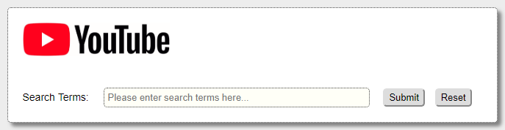
Design Requirements:
- The background colour for the main div element must be specified inline (see “Design Resources”).
- An arial font and 14px font size should be applied to the main div element.
- The above font and size declarations must be specified internally using a single ‘type’ selector.
- The form should display all results in a new window/tab.
- An absolute URL must be used as the image source (see “Design Resources”).
- An appropriate image size should be specified inline using the correct CSS declaration(s).
- A margin of 20px must be separately applied to the image and control/widget sections of the form.
- The above margin declaration should be specified internally using a ‘class’ selector.
- A label element must be used with the text description for each input field.
- A width of 350px should be applied to the input field using an inline CSS declaration.
- The background colour for all input fields must be specified internally (see “Design Resources”).
- A padding value of 5px and matching border effect should also be applied (see “Design Resources”).
- All declarations for the above two points must use a single ruleset with an ‘attribute’ selector.
- An arial font and 13px font size should be applied to all input elements.
- The above font and size declarations must be specified internally using a single ‘type’ selector.
- Suitable placeholder and required attributes should be included where appropriate.
- A rounding effect of 5px must be specified internally using a ‘class’ selector and applied as shown.
You will need to determine the value for both the form action and method attributes. Take some time to experiment with the YouTube search engine and review any examples covered in the lecture slides.
Design Resources:
Background (div) | #ffffff
Image File URL | https://mywebspace.net.au/DPIT128/assignment_2/images/youtube_logo.png
Background (input) | #fffff7
Border Effect | 1px dotted #404040
Please Note:
- HTML tables must not be used to layout this form.
- Each of the CSS rulesets provided in the template must be used within your final design.
- Be sure to include an appropriate/descriptive name for each of your ‘class’ selectors.
- This will be the first of 4 separate files that you must submit for this assignment.
This task is worth 2 marks.

Task 2: Complete the HTML and CSS code needed to create a slightly more elaborate form that interacts with the Google search engine. You must use the same layout and styling as shown below.
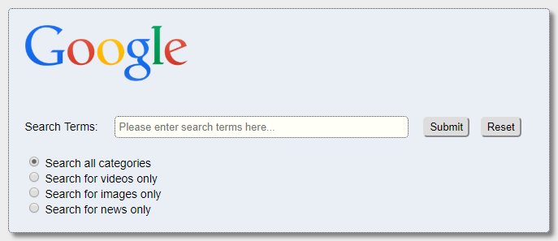
Design Requirements:
- The background colour for the main div element must be specified inline (see “Design Resources”).
- An arial font and 14px font size should be applied to the main div element.
- The above font and size declarations must be specified internally using a single ‘type’ selector.
- The form should display all results in a new window/tab.
- An absolute URL must be used as the image source (see “Design Resources”).
- An appropriate image size should be specified inline using the correct CSS declaration(s).
- A margin of 20px must be separately applied to the image and control/widget sections of the form.
- The above margin declaration should be specified internally using a ‘class’ selector.
- A label element must be used with the text description for each input field and radio button.
- A width of 350px should be applied to the input field using an inline CSS declaration.
- The background colour for all input fields must be specified internally (see “Design Resources”).
- A padding value of 5px and matching border effect should also be applied (see “Design Resources”).
- All declarations for the above two points must use a single ruleset with an ‘attribute’ selector.
- An arial font and 13px font size should be applied to all input elements.
- The above font and size declarations must be specified internally using a single ‘type’ selector.
- Suitable placeholder and required attributes should be included where appropriate.
- A rounding effect of 5px must be specified internally using a ‘class’ selector and applied as shown.
- All radio buttons should be grouped and the first/topmost must be selected by default.
You will need to determine the value for both the form action and method attributes. Take some time to experiment with the Google search engine and review any examples covered in the lecture slides.
Design Resources:
Background (div) | #eaeff6
Image File URL | https://mywebspace.net.au/DPIT128/assignment_2/images/google_logo.png
Background (input) | #fffff7
Border Effect | 1px dotted #404040
Please Note:
- HTML tables must not be used to layout this form.
- Each of the CSS rulesets provided in the template must be used within your final design.
- Be sure to include an appropriate/descriptive name for each of your ‘class’ selectors.
- This will be the second of 4 separate files that you must submit for this assignment.
This task is worth 2 marks.

Task 3: Complete the HTML and CSS code needed to create a slightly more elaborate form that interacts with the Target Australia search engine. You must use the same layout and styling as shown below.
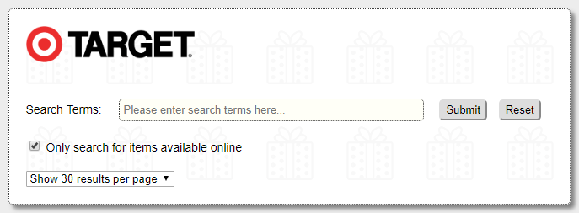
Design Requirements:
- The background image for the main div element must be specified inline (see “Design Resources”).
- An arial font and 14px font size should be applied to the main div element.
- The above font and size declarations must be specified internally using a single ‘type’ selector.
- The form should display all results in a new window/tab.
- An absolute URL must be used as the image source (see “Design Resources”).
- An appropriate image size should be specified inline using the correct CSS declaration(s).
- A margin of 20px must be separately applied to the image and control/widget sections of the form.
- The above margin declaration should be specified internally using a ‘class’ selector.
- A label element must be used with the text description for each input field and checkbox.
- A width of 350px should be applied to the input field using an inline CSS declaration.
- The background colour for all input fields must be specified internally (see “Design Resources”).
- A padding value of 5px and matching border effect should also be applied (see “Design Resources”).
- All declarations for the above two points must use a single ruleset with an ‘attribute’ selector.
- An arial font and 13px font size should be applied to all input and select elements.
- The above font and size declarations must be specified internally using combined ‘type’ selectors.
- Suitable placeholder and required attributes should be included where appropriate.
- A rounding effect of 5px must be specified internally using a ‘class’ selector and applied as shown.
- The select element should have two options for displaying either 30 or 90 results per page.
- The “Show 30 results per page” option must be selected by default.
- The “Only search for items available online” checkbox should be checked by default.
You will need to determine the value for both the form action and method attributes. Take some time to experiment with the Target Australia website and review any examples covered in the lecture slides.
Design Resources:
Background File URL | https://mywebspace.net.au/DPIT128/assignment_2/images/background.png
Image File URL | https://mywebspace.net.au/DPIT128/assignment_2/images/target_logo.png
Background (input) | #fffff7
Border Effect | 1px dotted #404040
Please Note:
- HTML tables must not be used to layout this form.
- Each of the CSS rulesets provided in the template must be used within your final design.
- Be sure to include an appropriate/descriptive name for each of your ‘class’ selectors.
- This will be the third of 4 separate files that you must submit for this assignment.
This task is worth 2 marks.

Task 4: Complete the HTML and CSS code needed to create a customer feedback form that interacts with a PHP form handler via the POST method. You must use the specification table included below as the basis for your final design.
Input Context | Control/Widget Type | Name Attribute Value
Full Name | Text | full-name
Email Address | Email | email-address
Services | Select (Multiple) | services[]
Comments | ??? | comments
Design Requirements:
- A background colour for the main div element must be specified inline (see “Design Resources”).
- An image has been provided and should be included within your solution (see “Design Resources”).
- A label element must be used with the text description for each control/widget (excluding buttons).
- A PHP form handler has also been provided and should be used for this task (see “Design Resources”).
All other relevant design parameters must match the specification given for the previous forms.
Design Resources:
Background (div) | #f9fff9
Image File URL | https://mywebspace.net.au/DPIT128/assignment_2/images/feedback_logo.png
PHP Handler URL | https://mywebspace.net.au/DPIT128/assignment_2/php/task_4.php
Important Tip: Use the feedback provided by the form handler to test your design. The output will clearly indicate if the information has been received correctly. Unsubmitted values will appear in red (see example 1) while values that have been correctly passed will appear in green (see example 2).
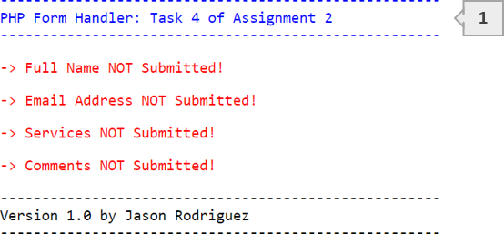
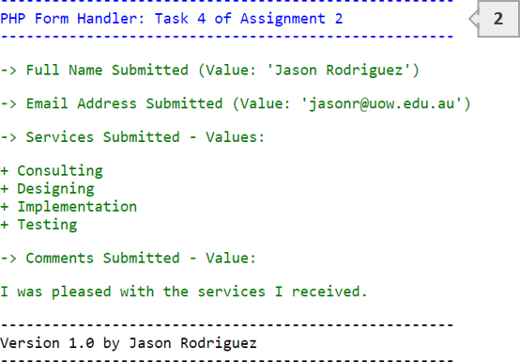
Please Note:
- HTML tables must not be used to layout this form.
- Each of the CSS rulesets provided in the template must be used within your final design.
- Be sure to include an appropriate/descriptive name for each of your ‘class’ selectors.
- This will complete the set of 4 separate files that you must submit for this assignment.
This task is worth 2 marks.

The following applies to all relevant components of your submission:
Additional Marking Criteria | Available Marks
Documents validate without issue(s) using the W3C HTML & CSS validators | 1.0
All URL values are absolute (includes both images and form handlers) | 0.25
All images have alt attributes with suitable/descriptive values | 0.25
HTML & CSS code is neat and suitably indented (2 Spaces Only) | 0.25
Documents contain explanatory HTML & CSS commenting where appropriate | 0.25
- THIS IS THE END OF THE ASSIGNMENT -
Version 2.2 by Jason Rodriguez

